Солдатова ФБ-11мп

Node cassandra1

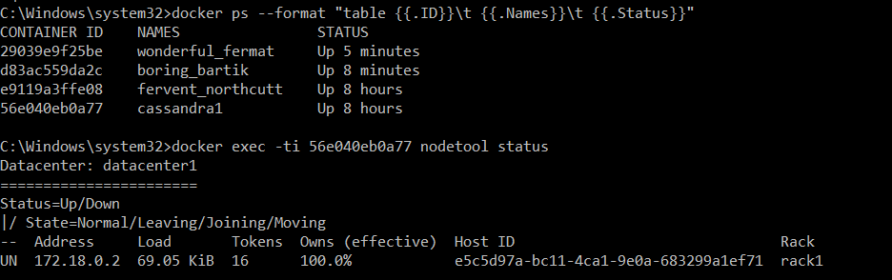

**Task 1.1**

> DESCRIBE TABLE items;

CREATE TABLE cycling.items (

category text,

price int,

id int,

model text,

producer text,

features map<text, text>,

PRIMARY KEY (category, price, model)

) WITH CLUSTERING ORDER BY (price ASC)

AND additional_write_policy = '99p'

AND bloom_filter_fp_chance = 0.01

AND caching = {'keys': 'ALL', 'rows_per_partition': 'NONE'}

AND cdc = false

AND comment = ''

AND compaction = {'class': 'org.apache.cassandra.db.compaction.SizeTieredCompactionStrategy', 'max_threshold': '32', 'min_threshold': '4'}

AND compression = {'chunk_length_in_kb': '16', 'class': 'org.apache.cassandra.io.compress.LZ4Compressor'}

AND crc_check_chance = 1.0

AND default_time_to_live = 0

AND extensions = {}

AND gc_grace_seconds = 864000

AND max_index_interval = 2048

AND memtable_flush_period_in_ms = 0

AND min_index_interval = 128

AND read_repair = 'BLOCKING'

AND speculative_retry = '99p';

CREATE INDEX features_indx ON cycling.items (values(features));

CREATE INDEX features_keys_indx ON cycling.items (keys(features));

CREATE INDEX producer_indx ON cycling.items (producer);

**Task 1.2**

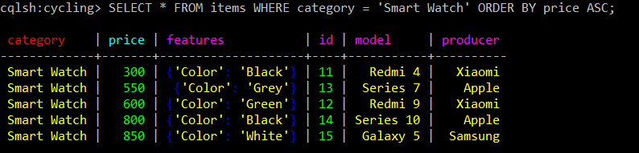

**Task 1.3**

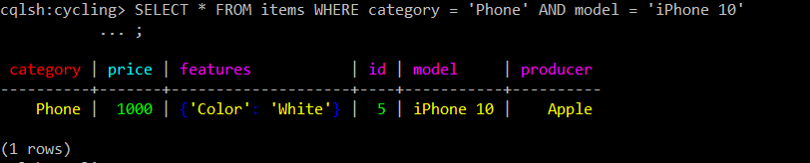

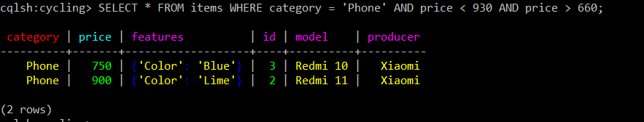

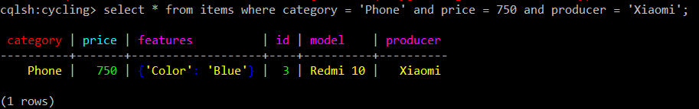

**Task 1.4**

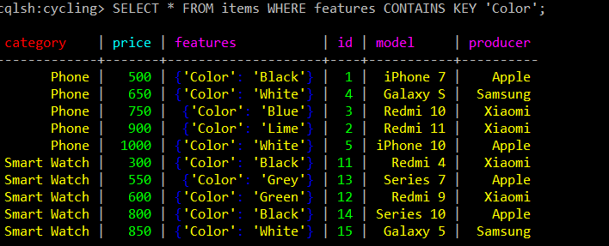

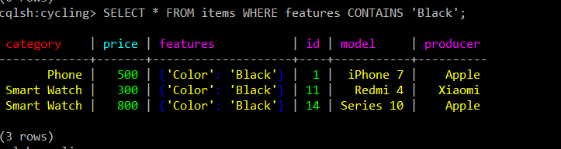

**Task 1.5**

> UPDATE items SET producer = 'Apple Inc' WHERE category = 'Phone' and price = 1000;

> UPDATE items SET producer = 'Apple Inc' WHERE category = 'Phone' and price = 500;

> UPDATE items SET producer = 'Apple Inc' WHERE category = 'Smart Watch' and price = 550;

> UPDATE items SET producer = 'Apple Inc' WHERE category = 'Smart Watch' and price = 800;

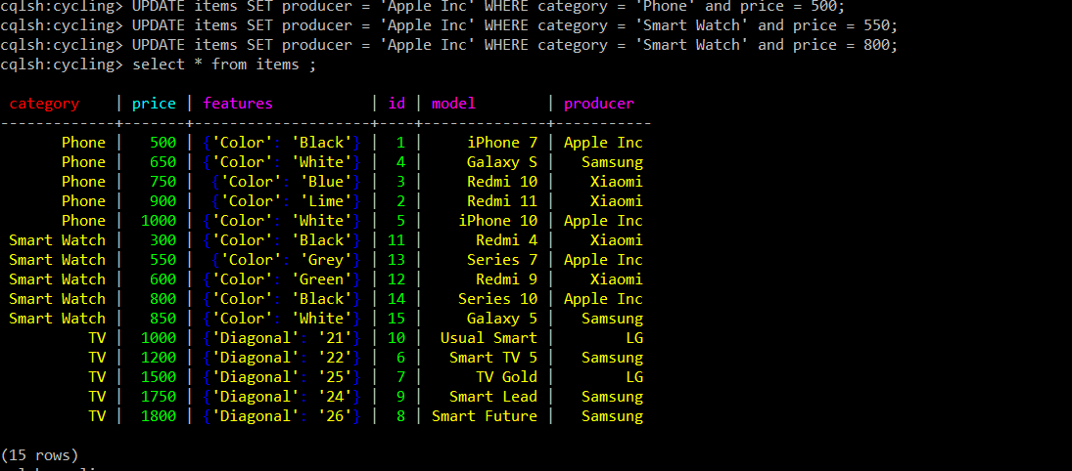

> UPDATE items SET features = {'Color':'Black','OS':'IOS'} WHERE category = 'Phone' AND price = 500 ;

> UPDATE items SET features = {'Color':'White','OS':'IOS'} WHERE category = 'Phone' AND price = 1000 ;

> UPDATE items SET features = {'Color':'White','OS':'Android'} WHERE category = 'Phone' AND price = 650 ;

> UPDATE items SET features = {'Color':'Blue','OS':'Android'} WHERE category = 'Phone' AND price = 750 ;

> UPDATE items SET features = {'Color':'Lime','OS':'Android'} WHERE category = 'Phone' AND price = 900 ;

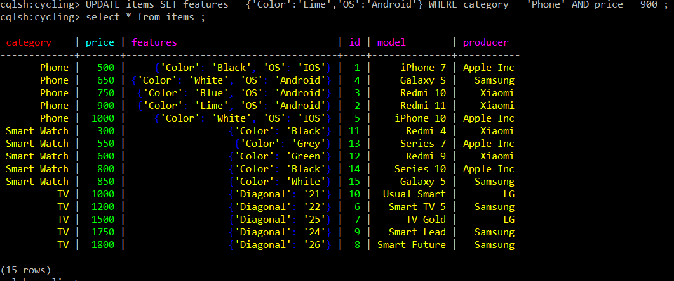

> DELETE features['Color'] FROM items WHERE category = 'Phone' IF EXISTS;

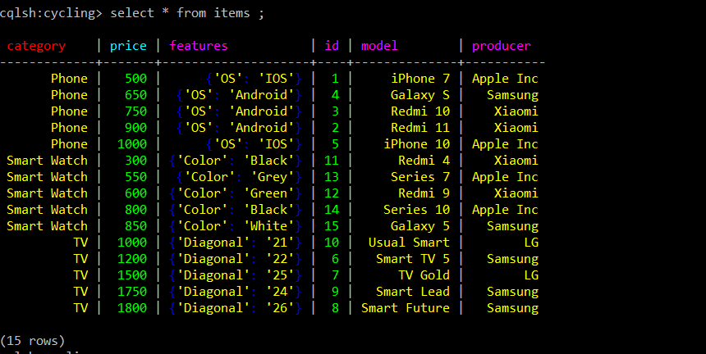

**Tasks 2**

CREATE TABLE cycling.orders (

customer <text>,

time timestamp,

id int,

total_price int,

items list<text>,

PRIMARY KEY (customer, time)

) WITH CLUSTERING ORDER BY (time DESC)

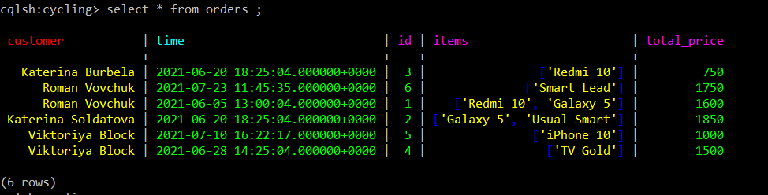

**Task 2.1**

> describe table orders;

CREATE TABLE cycling.orders (

customer text,

time timestamp,

id int,

total_price int,

items list<text>,

PRIMARY KEY (customer, time)

) WITH CLUSTERING ORDER BY (time DESC)

AND additional_write_policy = '99p'

AND bloom_filter_fp_chance = 0.01

AND caching = {'keys': 'ALL', 'rows_per_partition': 'NONE'}

AND cdc = false

AND comment = ''

AND compaction = {'class': 'org.apache.cassandra.db.compaction.SizeTieredCompactionStrategy', 'max_threshold': '32', 'min_threshold': '4'}

AND compression = {'chunk_length_in_kb': '16', 'class': 'org.apache.cassandra.io.compress.LZ4Compressor'}

AND crc_check_chance = 1.0

AND default_time_to_live = 0

AND extensions = {}

AND gc_grace_seconds = 864000

AND max_index_interval = 2048

AND memtable_flush_period_in_ms = 0

AND min_index_interval = 128

AND read_repair = 'BLOCKING'

AND speculative_retry = '99p';

CREATE INDEX items_indx ON cycling.orders (values(items));

CREATE INDEX price_indx ON cycling.orders (total_price);

CREATE INDEX time_indx ON cycling.orders (time);

**Task 2.2**

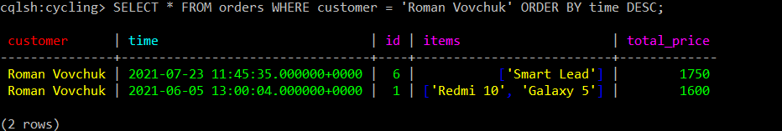

**Task 2.3**

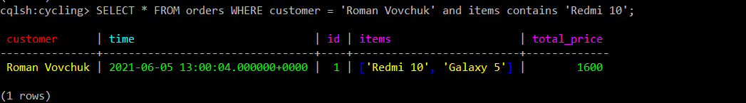

**Task 2.4**

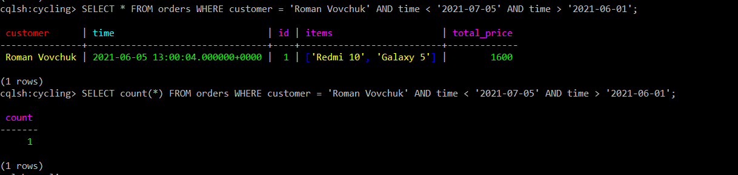

**Task 2.5**

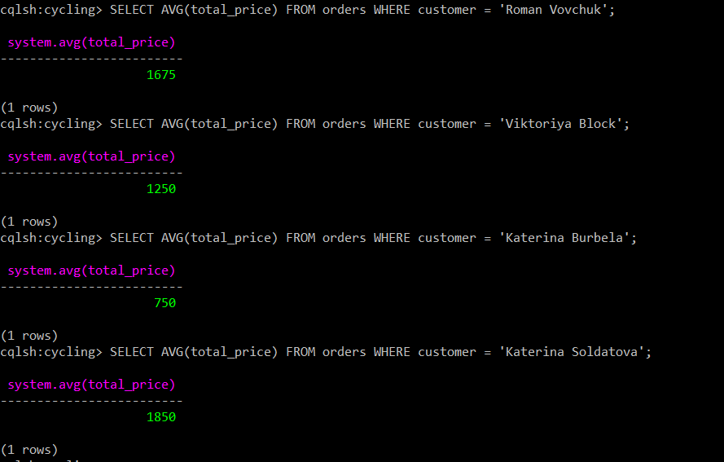

**Task 2.6**

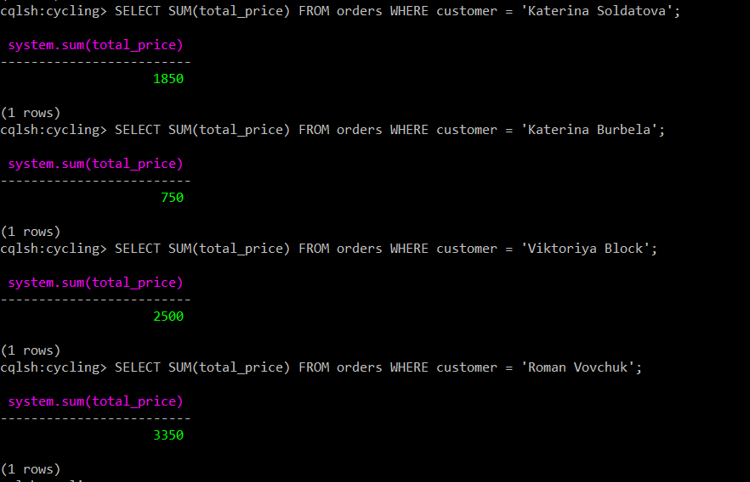

**Task 2.7**

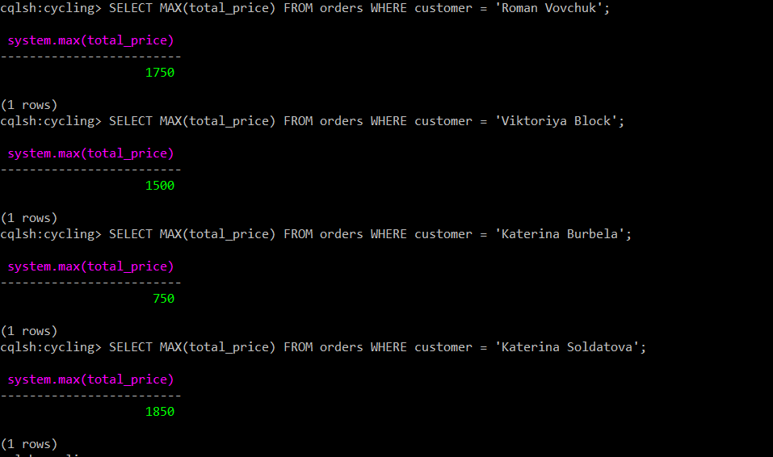

**Task 2.8**

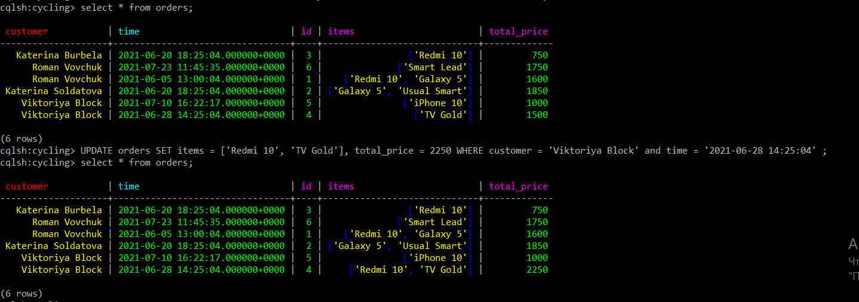

**Task 2.9**

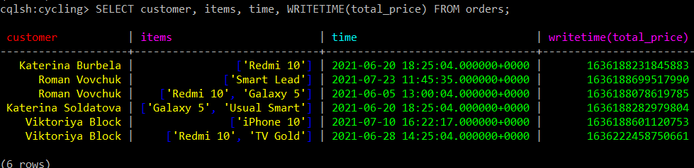

**Task 2.10**

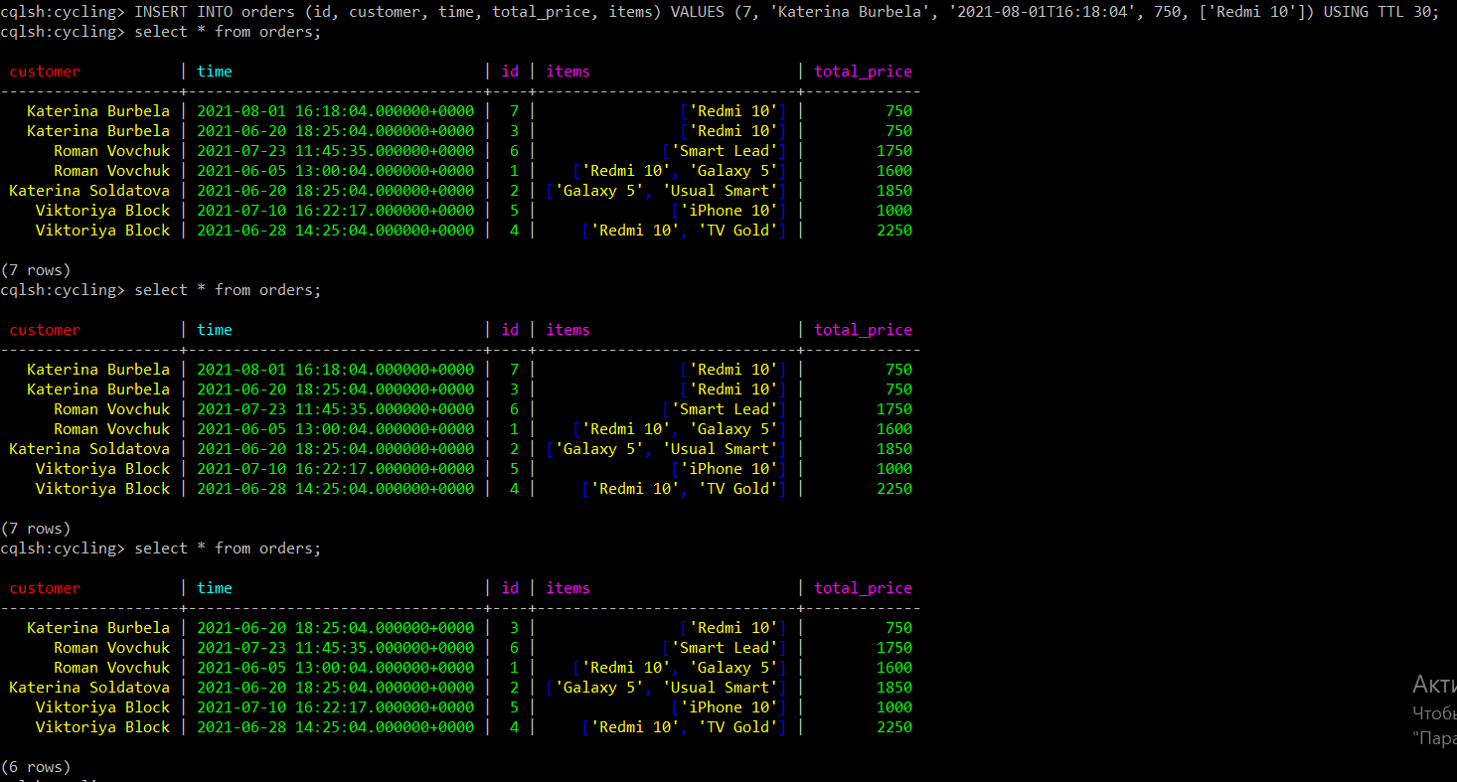

**Task 2.11**

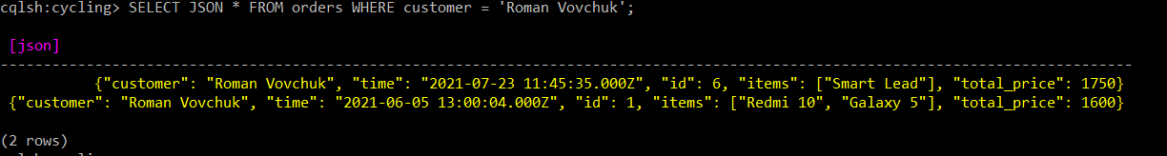

**Task 2.12**

